Lost & Found Person

A
Project Report
Submitted in partial fulfillment of the requirement for the award of degree of
Bachelor of Technology
In
Information Technology

Submitted to
RAJIV GANDHI PROUDYOGIKI VISHWAVIDYALAYA,
BHOPAL (M.P.)

Guided By Submitted By
Prof.(Dr.) Nitin Kulkarni Atharv Sharma (0827IT233D02)

DEPARTMENT OF INFORMATION TECHNOLOGY
ACROPOLIS INSTITUTE OF TECHNOLOGY & RESEARCH,
INDORE (M.P.) 453771
2024-2025

Declaration
I hereby declared that the work, which is being presented in the project entitled Lost & Found Person partial fulfillment of the requirement for the award of the degree of Bachelor of Technology, submitted in the department of Information Technology at Acropolis Institute of Technology & Research, Indore is an authentic record of my own work carried under the supervision of “Prof.(Dr.) Nitin Kulkarni” I have not submitted the matter embodied in this report for the award of any other degree.

Atharv Sharma (0827IT233D02)

Prof.(Dr.) Nitin Kulkarni
Supervisor

Project Approval Form
I hereby recommend that the project Lost & Found Person prepared under my supervision by Atharv Sharma (0827IT233D02) be accepted in partial fulfillment of the requirement for the degree of Bachelor of Technology in Information Technology.

Prof.(Dr.) Nitnin Kulkarni
Supervisor

Recommendation concurred in 2024-2025

Prof. Mahendra Verma
Project Incharge

Prof. Deepak Singh Chouhan
Project Coordinator

Acropolis Institute of Technology & Research
Department of Information Technology

Certificate
The project work entitled Lost & Found Person submitted by Atharv Sharma (0827IT233D02) is approved as partial fulfillment for the award of the degree of Bachelor of Technology in Information Technology by Rajiv Gandhi Proudyogiki Vishwavidyalaya, Bhopal (M.P.).

Internal Examiner External Examiner
Name:………………. Name: ……………..
Date: …./…/……….. Date: …./…/………..

Acknowledgement

With boundless love and appreciation, I would like to extend my heartfelt gratitude and appreciation to the people who helped me to bring this work to reality. I would like to have some space of acknowledgement for them.
Foremost, I would like to express my sincere gratitude to our supervisor, Prof. (Dr.) Nitin Kulkarni whose expertise, consistent guidance, ample time spent and consistent advice that helped me to bring this study into success.
To the project in-charge Prof. Mahendra Verma and project coordinator Prof. Deepak Singh Chouhan for their constructive comments, suggestions, and critiquing even in hardship.
To the honorable Prof. (Dr.) Prashant Lakkadwala, Head, Department of Information Technology for his favorable responses regarding the study and providing necessary facilities.
To the honorable Dr. S.C. Sharma, Director, AITR, Indore for his unending support, advice and effort to make it possible.
Finally, I would like to pay my thanks to faculty members and staff of the Department of Information Technology for their timely help and support.
I also like to pay thanks to my parents for their eternal love, support and prayers without them it is not possible.
Atharv Sharma (0827IT233D02)

Abstract
The project titled “Lost & Found Person ” aims to develop an intelligent, AI-powered platform that automates and simplifies the process of locating missing individuals and recovering lost belongings.

What was done:
A unified web-based and mobile system was designed and implemented where users can report missing persons or lost items by uploading images, descriptions, and last-known locations. The system applies artificial intelligence algorithms to automatically compare new reports with existing records, identify possible matches, and alert nearby users and authorities in real time.

Why it was done:
Existing systems for tracking missing persons are mostly manual, fragmented, and inefficient—relying on FIRs, posters, or social media. Such methods delay communication and limit public participation. This project was undertaken to create a centralized, automated solution that integrates technology, community effort, and administrative verification to increase the success rate of recoveries and reduce response time.

How it was done:
The system was developed using ReactJS/Flutter for the frontend and Spring Boot for backend services. AI models implemented with TensorFlow and OpenCV perform facial recognition and object detection to identify matches. MongoDB stores user data and reports, while Google Maps API, Firebase, and Twilio provide geolocation and real-time alert functionalities. The algorithms studied and implemented include Viola-Jones, SMQT + SNOW Classifier, Neural Networks, and Support Vector Machines (SVM) for comparison and optimization.

What was found:
Among the evaluated algorithms, the Viola-Jones approach demonstrated the best trade-off between accuracy and speed, achieving high precision and recall for facial detection tasks, making it suitable for real-time applications.

Significance of the findings:
The developed system successfully demonstrates how artificial intelligence and community-driven participation can enhance social safety.

Table of Content
Declaration …………………………………………………………………………. 02
Project Approval Form …………………………………………………………… 03
Acknowledgement ………………………………………………………………… 05
Abstract ……………………………………………………………………………. 06
List of Figures…………………………………………………………………….... 10
List of Tables……………….………………………………………………………. 11
Abbreviations………………………………………………………………………. 12
Chapter 1: Introduction
1.1 Rationale ………………………………………………………………... 13
1.2 Existing System ………………………………………………………… 14
1.3 Problem Formulation……………………………………………………. 15
1.4 Proposed System……………………………………………………….... 16
1.5 Objectives……………………………………………………………….. 17
1.6 Contribution of the Project……………………………………………… 18
1.6.1 Market Potential………………………………………………. 18
1.6.2 Innovativeness………………………………………………… 18
1.6.3 Usefulness…………………………………………………….. 19
1.7 Report Organization…………………………………………………….. 20
Chapter 2: Requirement Engineering……………………………………………. 22
2.1 Feasibility Study (Technical, Economical, Operational)……………….. 22
2.2 Requirement Collection………………………………………………… 23
2.2.1 Discussion……………………………………………………. 23
2.2.2 Requirement Analysis……………………………………….. 24
2.3 Requirements…………………………………………………………... 24
2.3.1 Functional Requirements……………………....................... 24
2.3.1.1 Statement of Functionality……………………......... 25
2.3.2 Nonfunctional Requirements…………………….................... 26
2.3.2.1 Statement of Functionality…………………………. 28
2.4 Hardware & Software Requirements…………………………………... 29
2.4.1 Hardware Requirement (Developer & End User)……………. 29
2.4.2 Software Requirement (Developer & End User)…………….. 30
2.5 Use-case Diagrams……………………………………………………... 31
2.5.1 Use-case Descriptions……………………………………….... 31
Chapter 3: Analysis & Conceptual Design & Technical Architecture...……… 32
3.1 Technical Architecture……………………………………………… 32
3.2 Sequence Diagrams………………………………………………… 32
3.3 Class Diagrams……………………………………………………… 33
3.4 DFD…………………………………………………………………. 34
3.5 User Interface Design ………………………………………………. 34
3.6 Data Design…..……………………………………………………... 34
3.6.1 Schema Definitions…………………………………………… 34
3.6.2 E-R Diagram………………………………………….. 34
Chapter 4: Implementation & Testing…………………………………………… 35
4.1 Methodology………………………………………………………. 35
4.1.1 Proposed Algorithm………………………………….... 36
4.2 Implementation Approach………………………………………….. 38
4.2.1 Introduction to Languages, IDEs Tools and Technologies…….. 40
4.3 Testing Approaches…………………………………………………….... 41
4.3.1 Unit Testing…………………………………………………..... 41
a. Test Cases…………………………………………………. 42
4.3.2 Integration Testing……………………………………………… 42
b. Test Cases………………………………………………….. 43
Chapter 5: Results & Discussion………………………………………………….... 44
5.1 User Interface Representation………………………………………….…. 44
5.1.1 Brief Description of Various Modules……………………….…. 45
5.2 Snapshot of System with Brief Description…………………………….… 48
5.3 Database Description……………………………………………………… 49
5.3.1 Snapshot of Database Tables with Brief Description…………… 51
5.4 Final Findings……………………………………………………………... 56
6. Conclusion & Future Scope………………………………………………………. 59
6.1 Conclusion ………………………………………………………………... 59
6.2 Future Scope………………………………………………………………. 60
REFERENCES………………………………………………………………………. 62
Appendix A: Project Synopsis………………………………………………………... 62
Appendix B: Guide Interaction Report ………………………………………………. 62
Appendix C: User Manual …………………………………………………………… 62
Appendix D: Git/GitHub Commits/Version History…………………………………. 62

List of Figures
Figure No. | Figure Title | Page No.
Figure 2.3 | Use Case Diagram of the System | 24
Figure 3.1 | Technical Architecture of the Missing Person & Lost Item Tracker | 32
Figure 3.4 | Data Flow Diagram (DFD) Level 1 | 34
Figure 5.1 | User Interface Layout of the System | 44
Figure 5.3.1(a) | Snapshot of User Collection | 51
Figure 5.3.1(b) | Snapshot of Report Collection | 52
Figure 5.3.1(c) | Snapshot of AI Result Collection | 53
Figure 5.3.1(d) | Snapshot of Notification Collection | 54
Figure 5.3.1(e) | Snapshot of Admin Collection | 55

List of Tables
Table No. | Table Title | Page No.
Table 4.3.2.1 | Integration Test Scenarios and Results | 42
Table 5.3.1 | Description of Major Database Collections | 43
Table 5.4 | Summary of Functional and Non-Functional Findings | 56

Abbreviations
Abbreviation | Full Form
AI | Artificial Intelligence
ML | Machine Learning
CNN | Convolutional Neural Network
DB | Database
UI | User Interface
UX | User Experience
API | Application Programming Interface
JWT | JSON Web Token
DFD | Data Flow Diagram
ER | Entity-Relationship
FCM | Firebase Cloud Messaging
IDE | Integrated Development Environment
IoT | Internet of Things
SSL/TLS | Secure Socket Layer / Transport Layer Security
NLP | Natural Language Processing
GAN | Generative Adversarial Network
ViT | Vision Transformer
CRUD | Create, Read, Update, Delete
URL | Uniform Resource Locator
JSON | JavaScript Object Notation
HTTP | HyperText Transfer Protocol

Chapter 1: Introduction
  - Rationale
In today’s fast-paced and technologically advanced world, the number of missing persons and lost items has been increasing at an alarming rate, creating emotional distress for families and posing a serious challenge to law enforcement agencies. Every year, thousands of people, including children, elderly citizens, and mentally challenged individuals, go missing due to various reasons such as accidents, abductions, migration, or memory disorders. Similarly, people lose valuable items like mobile phones, wallets, and luggage, especially in crowded places such as airports, railway stations, hospitals, and public gatherings. Despite the availability of digital platforms and communication tools, current methods of tracking and recovery remain largely manual, fragmented, and inefficient.
The traditional approach involves filing an FIR (First Information Report) at a nearby police station or spreading the word through posters, newspapers, and social media platforms. Although these methods help in raising awareness, they are time-consuming, lack coordination, and often rely on luck rather than systematic data analysis. Law enforcement agencies, NGOs, and citizens maintain isolated records, which creates redundancy and hampers effective data sharing. Moreover, most of these systems lack any intelligent search or image recognition features, making it difficult to identify or match individuals based on visual or contextual similarities.
The rationale behind developing the “Missing Person & Lost Item Tracker” lies in addressing these long-standing issues by creating a centralized, AI-driven, and community-supported solution. This project aims to bridge the gap between the general public and authorities by leveraging Artificial Intelligence (AI), Machine Learning (ML), and Computer Vision technologies. Using algorithms such as Viola-Jones, Neural Networks, and SVM classifiers, the system can automatically detect, recognize, and match faces or objects from uploaded images with those stored in the database. This intelligent automation drastically reduces human effort, minimizes response time, and enhances the accuracy of identification.
Furthermore, by integrating APIs like Firebase and Twilio, the system enables real-time notifications and location tracking, ensuring that users and authorities receive instant alerts when potential matches are found. The incorporation of Google Maps API allows visualization of last-seen locations and facilitates better route planning for search operations. The platform also ensures data security and privacy, with encrypted storage and verified reporting features to prevent misuse or duplication.
From a societal perspective, this project plays a crucial role in promoting public safety and social responsibility. It empowers ordinary citizens to contribute actively by reporting sightings or submitting information, thereby creating a collaborative ecosystem between the community and law enforcement agencies. On a larger scale, it supports government initiatives toward smart policing and smart city development, where technology-driven solutions are integrated to enhance public welfare and safety.
  - Existing System
In the current scenario, the methods used to locate missing persons or recover lost items are largely manual, disorganized, and inefficient. Despite advancements in digital communication, most existing systems rely on traditional practices such as lodging police complaints, circulating physical posters, posting information on social media, and broadcasting news through television or local newspapers. While these methods spread awareness, they are time-consuming, non-interactive, and lack a centralized mechanism for data management and real-time search.
Typically, when a person goes missing, their family members file an FIR (First Information Report) at a nearby police station. The police then circulate this information to various stations, but the process is slow and dependent on human coordination. Similarly, missing posters with photographs and brief descriptions are pasted in public places, hoping that someone might recognize the individual. However, such manual tracking often fails in metropolitan areas due to population density, limited reach, and the absence of automated recognition systems.
For lost items, the challenge is even greater. People usually post on social media or depend on local announcements to retrieve their belongings. There is no official or structured system that records, classifies, or matches lost item reports with recovered ones. Moreover, without image-based recognition, most recoveries rely solely on textual descriptions, which can be ambiguous and prone to human error.
While some government portals and NGO platforms exist for registering missing persons, they operate independently, leading to data fragmentation. These platforms lack integration with AI or image-processing technologies, resulting in low accuracy and delayed results. Furthermore, there is no mechanism for cross-verification or authentication, making it difficult to distinguish genuine cases from false or duplicate entries.
Additionally, data privacy and security are not adequately addressed in most of the existing systems. Sensitive personal information such as images, contact numbers, and location details are often stored in unsecured databases or shared across platforms without encryption, leading to misuse or unauthorized access.
In summary, the existing system suffers from the following drawbacks:
- Lack of centralized and automated tracking mechanisms.
- Manual processes leading to delayed communication.
- No real-time alerts or AI-based identification features.
- Poor coordination between public users and law enforcement agencies.
- Inadequate data security and verification mechanisms.

  - Problem Formulation
The issue of tracking missing persons and lost items remains a complex and persistent problem, even in today’s age of digital transformation. Despite advancements in communication and technology, the process of reporting, searching, and recovering missing individuals or lost objects still depends heavily on manual, unstructured, and decentralized methods. The lack of coordination among different stakeholders—such as the general public, police departments, and NGOs—results in significant delays and inefficiencies in locating the concerned person or object.
Currently, there is no unified digital platform that integrates artificial intelligence, community participation, and administrative verification under one ecosystem. The traditional methods rely on human memory and manual image comparisons, which are prone to errors and time delays. Families often struggle to get timely updates or verification about their missing relatives. Similarly, lost items such as luggage, mobile devices, or personal documents may be recovered by someone but remain unclaimed because there is no automated system that matches lost and found reports efficiently.
The key problem lies in the absence of automation and intelligent data handling. Existing government portals or online forms only store textual information, which is difficult to match without image-based recognition. This limitation reduces the probability of successful identification, especially when facial features or object appearances change over time or under different conditions. Moreover, the lack of real-time alert mechanisms means that even when a potential match is found, it may take days before the relevant people are notified.

Another critical issue is the security and authenticity of data. False reporting, duplication of entries, and misuse of personal information can compromise both the effectiveness and credibility of such systems. Therefore, a reliable solution must include secure authentication, data validation, and controlled access for authorized personnel.
Hence, the problem can be formulated as the need to design and implement an AI-based intelligent platform that can automatically process and analyze images of missing persons or lost items, compare them with a centralized database, and instantly notify relevant authorities and users in case of probable matches. The system must ensure data security, accuracy, real-time communication, and ease of use for the general public as well as law enforcement.
In conclusion, the formulated problem is to bridge the gap between manual reporting and automated intelligent detection, thereby developing a unified platform that enhances the speed, reliability, and success rate of recovering missing persons and lost belongings.

  - Proposed System
The Lost & Found Person has been proposed as a smart, AI-enabled, and centralized web-based platform that addresses the shortcomings of existing manual systems for identifying missing persons and locating lost items. The main concept behind this system is to leverage Artificial Intelligence (AI) and Machine Learning (ML) techniques—particularly facial recognition and object detection—to create an intelligent, automated process for comparing uploaded images and information with existing records. This integration of automation, real-time data sharing, and geo-location tracking is intended to make the process of searching and recovery significantly faster, more accurate, and more reliable.
In the proposed system, users can easily register and log in to the platform using secure authentication methods. Once logged in, they can create new reports for missing persons or lost items by uploading images, providing descriptive details, and tagging the last known location. The system then processes the uploaded image using AI algorithms such as Viola-Jones, SMQT + SNOW classifier, and Convolutional Neural Networks (CNN) to detect facial or object features. These extracted features are automatically compared with existing records in the database to identify potential matches.
If a match is found, the system triggers real-time notifications via Firebase Cloud Messaging or Twilio API to inform the registered users and nearby authorities. The Google Maps API is used to visualize the location of the last sighting and possible current area based on crowd-sourced data. This helps both users and authorities to take immediate action and coordinate searches effectively.
The backend system, developed using Spring Boot (Java), ensures secure data processing and high-performance communication between the frontend and the AI engine. The frontend interface, built with ReactJS for web and Flutter for mobile devices, provides an intuitive and user-friendly experience. The database, powered by MongoDB, efficiently handles image storage, metadata, and report records, ensuring scalability and reliability.
Additionally, an admin dashboard allows authorized personnel, such as police officers or NGO representatives, to verify, update, and close cases once resolved. The system also incorporates role-based access control, ensuring that only verified individuals can access sensitive data or perform administrative actions.
In summary, the proposed system provides a comprehensive, automated, and intelligent platform that unites technology and community participation. It eliminates manual inefficiencies by offering a unified portal where citizens, police, and organizations can collaborate effectively. Through its AI-driven image matching, secure cloud-based architecture, and real-time alerts, the Lost & Found Person aims to revolutionize how missing persons and lost belongings are reported, tracked, and recovered in today’s society.

  - Objectives
The main objective of the Lost & Found Person project is to design and develop a centralized, intelligent, and user-friendly platform that helps in the identification and recovery of missing persons and lost belongings through the application of Artificial Intelligence (AI) and real-time communication technologies. The project aims to integrate automation, data analytics, and community participation to transform manual and inefficient processes into a faster, more reliable, and scalable digital ecosystem.
The primary goal is to reduce the time taken to locate missing persons and lost items by implementing advanced facial recognition and object detection algorithms. The system should be capable of comparing newly uploaded images with existing records in the database and automatically identifying potential matches based on visual similarity and contextual information. Once a probable match is found, instant alerts and notifications should be sent to the concerned individuals and authorities for further verification and action.
Another major objective is to ensure data centralization and transparency. Currently, information related to missing individuals or found items is dispersed across various platforms such as police stations, social media, and NGO databases. The proposed system consolidates this scattered data into a single, secure database that can be accessed and updated by authorized users in real time.
The project also aims to provide a user-friendly interface that enables non-technical users to easily register, report, and track cases. The interface should include features such as image upload, location tagging, filtering, and searching of reports. Moreover, the system is designed to support both web and mobile platforms to maximize accessibility and convenience.
Security and authenticity are also key objectives. The platform incorporates data encryption, role-based access control, and verification procedures to prevent false reporting and unauthorized access. This ensures that the integrity of the system is maintained and that sensitive information is protected.
Furthermore, the project seeks to enhance collaboration between citizens, law enforcement agencies, and social organizations by creating a transparent and responsive ecosystem. The inclusion of real-time communication tools, such as Firebase and Twilio, allows for immediate alerts and status updates, making the entire process more interactive and efficient.

  - Contribution of the Project
    - Market Potential
The Lost & Found Person holds significant market potential because it addresses a widespread and persistent issue that affects individuals, families, organizations, and law enforcement agencies across the globe. The increasing frequency of missing person incidents and lost property cases, combined with the rapid advancement of artificial intelligence and cloud computing, creates an ideal environment for the implementation and expansion of such a solution.
In India alone, thousands of cases of missing individuals are reported every year, and many go unresolved due to the lack of efficient systems for tracking and verification. Similarly, valuable items such as mobile phones, laptops, and identification documents are lost daily in public spaces like airports, hospitals, schools, malls, and railway stations. Despite the scale of the problem, very few digital platforms exist that provide intelligent, automated, and centralized solutions. This project directly fills that void, presenting strong opportunities for public adoption and institutional partnerships.
The system can be implemented in collaboration with government bodies, such as the police department, municipal corporations, and national identity authorities, to create a nationwide digital network for missing and found reports. Such integration can modernize the way information is shared among different districts, police stations, and agencies, reducing redundancy and improving coordination.
    - Innovativeness
The Lost & Found Person project stands out for its innovative use of Artificial Intelligence (AI), real-time communication technologies, and community participation to address one of the most pressing social challenges — locating missing individuals and recovering lost belongings. What sets this project apart from traditional systems is its ability to integrate multiple intelligent modules into a unified, automated platform capable of self-learning, recognition, and alert generation with minimal human intervention.
One of the major innovations lies in the AI-based image analysis and recognition system. Traditional missing person tracking relies heavily on manual verification of photographs or descriptions, which is time-consuming and often inaccurate. In contrast, this project employs computer vision algorithms such as Viola-Jones, SMQT + SNOW classifier, and Neural Networks (CNN) for automatic detection and identification. These algorithms are capable of recognizing facial features and object characteristics even under varying conditions such as lighting, pose, or occlusion, thereby improving both precision and recall rates.
Another key innovation is the system’s ability to perform real-time data processing and communication. Through integration with Firebase Cloud Messaging and Twilio APIs, the platform provides instant alerts to users and authorities whenever a potential match is detected. This feature minimizes response time and ensures that timely action can be taken in critical situations. Furthermore, the inclusion of the Google Maps API enables precise visualization of the last-seen locations, helping authorities and users to geographically trace individuals or items more effective
    - Usefulness
The Lost & Found Person project is highly useful both from a technological and societal perspective. It directly addresses real-world issues of missing individuals and lost belongings by providing an efficient, accessible, and intelligent system that bridges the communication gap between the public, law enforcement agencies, and support organizations. Its practical applications extend across multiple sectors — from policing and public safety to transportation, education, and community welfare.
At the core of its usefulness is the system’s ability to automate detection and reporting using Artificial Intelligence (AI). Traditionally, identifying missing persons or lost items required manual searching, physical verification, or community awareness drives. These processes are slow, inconsistent, and often ineffective in high-density areas. By contrast, the proposed system enables automated face and object recognition, drastically reducing the time required to identify matches. The use of algorithms like Viola-Jones, Neural Networks, and Support Vector Machines (SVM) ensures reliable detection even under challenging conditions such as low lighting or partial visibility.
The platform’s real-time alert mechanism adds immense practical value. Through the integration of Firebase and Twilio APIs, users and authorities receive instant notifications when a possible match is found. This immediate communication allows families and officials to act quickly, often making the difference between successful and failed recovery operations.
From a public engagement standpoint, the project’s usefulness lies in its ability to involve the community directly. It provides an open yet secure environment where individuals can contribute by reporting missing persons, found items, or relevant sightings. This collective participation increases visibility, enhances the speed of information exchange, and builds a collaborative social network centered on safety and responsibility.

- Report Organization?
This report is systematically structured into six comprehensive chapters, each addressing a specific stage of the project’s conception, development, and evaluation. The organization follows a logical sequence to help the reader clearly understand the problem background, the technical implementation, and the outcomes achieved. It provides both theoretical understanding and practical insights into how the Lost & Found Person system was developed and tested.

Chapter 1: Introduction
This chapter provides an overview of the project and the motivation behind its development. It outlines the rationale, discusses the existing system and its shortcomings, formulates the problem statement, and introduces the proposed system. The chapter also defines the project’s objectives, its contributions to technology and society, and its market potential. Further, it highlights the innovative aspects and usefulness of the system. The chapter concludes by describing how the rest of the report is organized.

Chapter 2: Requirement Engineering
This chapter details the process of gathering, analyzing, and defining the requirements necessary for the successful development of the system. It includes a feasibility study covering technical, economic, and operational aspects. Functional and non-functional requirements are described thoroughly, along with the hardware and software requirements for both developers and end users. The chapter also presents the system’s use-case diagrams and their descriptions, which illustrate the interactions between users and the system.

Chapter 3: Analysis, Conceptual Design, and Technical Architecture
This chapter explains the system’s design and structure. It includes the technical architecture, sequence and class diagrams, data flow diagrams (DFDs), and user interface designs. The database design, schema definitions, and E-R diagrams are discussed to provide a detailed understanding of how data is processed, stored, and retrieved within the system.

Chapter 4: Implementation and Testing
This chapter focuses on the practical implementation of the project. It explains the development methodology, algorithms used, technologies adopted, and testing strategies. Detailed discussions on unit testing, integration testing, and test case design demonstrate the system’s reliability and performance under various conditions.

Chapter 5: Results and Discussion
In this chapter, the outcomes of the implemented system are presented. Screenshots of user interfaces, database entries, and AI results are shown and discussed. The chapter analyzes the system’s effectiveness, performance accuracy, and user feedback.

Chapter 6: Conclusion and Future Scope
The final chapter summarizes the overall work, key findings, and the impact of the developed system. It also discusses potential enhancements and areas for future research, such as advanced AI integration, CCTV data analysis, and nationwide deployment.

Chapter 2: Requirement Engineering
  - Feasibility Study (Technical, Economical, Operational)
- Technical Feasibility
The technical feasibility focuses on the system’s hardware, software, and technological requirements. The proposed solution employs modern and reliable technologies such as Spring Boot (Java) for backend development, ReactJS and Flutter for frontend interfaces, and MongoDB as the primary database. These technologies are open-source, well-supported, and scalable, making them suitable for handling large datasets and concurrent user operations.
For AI-based recognition, frameworks like TensorFlow, OpenCV, and Scikit-learn are used to implement facial recognition and object detection algorithms. These libraries have proven efficiency and accuracy in real-time image processing tasks. Cloud platforms such as Firebase are integrated for data storage, authentication, and notification services, while Twilio APIs facilitate instant communication between users and authorities.
Additionally, the system requires moderate computational resources — an Intel i7/Ryzen 7 processor, 16 GB RAM, and a GPU (like NVIDIA GTX 1660 or higher) are sufficient for AI operations. This ensures that even small organizations or institutions can deploy and maintain the system without excessive infrastructure costs.
- Economic Feasibility
The project is economically feasible as it utilizes open-source frameworks and tools, which significantly reduce software licensing costs. The deployment can be hosted on low-cost cloud platforms such as Firebase or AWS Free Tier. Maintenance costs are minimal since most updates are automated through version control systems like GitHub. In addition, because the system can be extended to public and private institutions, it has strong potential for government funding, CSR initiatives, and NGO collaborations.
- Operational Feasibility
Operational feasibility examines whether the system will function effectively in the intended environment and meet user needs. The user interface is designed to be simple, intuitive, and accessible for people with limited technical knowledge. The reporting and verification workflows are streamlined for both users and administrators. Training requirements are minimal since the system operates through guided interfaces and predefined steps. Moreover, the real-time alert and notification features ensure continuous engagement and quick decision-making.
  - Requirement Collection
Before designing and implementing the Missing Person & Lost Item Tracker, it was essential to perform a thorough requirement collection process. This phase helps ensure that the system’s functionalities align with user expectations, operational needs, and technical feasibility. The process involved gathering inputs from end-users, law enforcement officials, NGOs, and technical experts to identify both the functional and non-functional requirements essential for building an effective and reliable system.
    - Discussion
The requirement collection phase began with multiple interviews, surveys, and observation sessions involving individuals who had firsthand experience with missing person cases or lost item recovery efforts. Discussions were conducted with police officers from the local station, social service volunteers, and citizens who had reported such incidents in the past. The purpose was to understand their challenges, expectations, and pain points when dealing with existing systems.
From these sessions, it was evident that current solutions lacked automation, synchronization, and reliable data verification. Users emphasized the need for a centralized digital platform where they could report, search, and receive updates in real time. Authorities highlighted the importance of authentication, data accuracy, and verification to prevent false or duplicate entries. Additionally, the need for an intuitive interface accessible from both desktop and mobile devices was strongly emphasized, especially for people who may not be tech-savvy.
Further technical discussions with developers and AI specialists helped in identifying suitable machine learning algorithms and software frameworks that could achieve high performance without overloading system resources. It was agreed that the system should include image recognition, location tagging, and automated notifications as core features, supported by a secure database and an admin verification layer.

    - Requirement Analysis
After collecting and reviewing the discussions and survey data, the requirements were categorized into functional and non-functional groups. Functional requirements define the specific behaviors and operations of the system, while non-functional requirements outline the quality attributes such as performance, security, and usability.
The functional requirements included the ability for users to register, upload reports with images and details, search existing entries, and receive real-time notifications. The admin users were expected to verify cases, manage reports, and update the database. The AI component was expected to compare new uploads with existing records using recognition algorithms and return possible matches with confidence scores.
The non-functional requirements focused on ensuring speed, reliability, scalability, and security. The system needed to process image comparisons within a few seconds, maintain consistent uptime, and secure sensitive user data using encryption and authentication mechanisms.
In addition to these, environmental and usability requirements were considered — ensuring that the system would run smoothly on standard hardware and browsers and could handle a growing number of users and reports over time.
  - Requirements
A well-defined set of requirements forms the backbone of any successful software project. For the Missing Person & Lost Item Tracker, the requirements were carefully designed after analyzing user needs, environmental conditions, and technical capabilities. These requirements ensure that the system achieves its intended objectives — to identify, match, and recover missing persons or lost items efficiently, accurately, and securely. The requirements were broadly categorized into functional and non-functional components, each serving a distinct purpose in the system’s development and performance.
    - Functional Requirements
Functional requirements describe the operations and features the system must support. They define how the system behaves in response to user actions and how it interacts with external systems. The major functional requirements for the project are as follows:
- User Registration and Authentication:
Users must be able to create an account and securely log in using credentials. Authentication ensures that data submissions and reports are from verified sources, minimizing misuse.
- Report Creation for Missing Persons and Lost Items:
The system allows users to submit a report by uploading an image, entering a description, providing contact details, and tagging the last-seen location using the Google Maps API.
- AI-Based Matching:
The core functionality is powered by facial recognition and object detection algorithms such as Viola-Jones, SMQT + SNOW, and Neural Networks, which compare uploaded images with existing records to identify potential matches.
- Real-Time Notifications:
Through Firebase or Twilio APIs, the system sends immediate alerts to the user and authorities when a potential match is detected.
- Search and Filter Functionality:
Users can search existing reports using keywords, date ranges, or location-based filters to find relevant cases quickly.
- Admin Verification and Case Management:
Admins can verify reports, approve or reject submissions, and update the case status once resolved to maintain data authenticity.
- Data Storage and Retrieval:
The system uses MongoDB to store user details, image data, and report histories efficiently, ensuring easy retrieval and scalability.
      - Statement of Functionality
The Missing Person & Lost Item Tracker system provides a comprehensive set of functional requirements that define how the application behaves and interacts with users, the database, and the AI components. These functionalities ensure that the system performs its intended operations efficiently and reliably. Each function was designed to support the project’s main goal — enabling users to report, search, and verify missing persons or lost items using artificial intelligence and real-time notifications.
1. User Registration and Authentication
- Users can create accounts through a registration form using valid email, mobile number, and password.
- Authentication is handled securely through Firebase Authentication, ensuring that only authorized users can access the system.
- Passwords are encrypted before being stored in the database.
2. Report Submission
- Users can submit reports for missing persons or lost items by filling out forms containing essential details such as name, description, and location.
- Each report allows image uploads, which are processed and stored in Firebase Cloud Storage, with metadata stored in MongoDB.
- The system automatically assigns a unique report ID for each submission.
3. AI-Based Image Analysis
- The AI Engine (Python – TensorFlow, OpenCV) analyzes submitted images and compares them with existing records.
- It calculates a confidence score to determine potential matches.
- Reports with a high similarity threshold (≥ 90%) are flagged and sent for administrative verification.
4. Search and Match Functionality
- Users can search the database by name, description, or category.
- Admins and authorities can view matched results and detailed case information.
- The AI module supports both facial recognition and object matching for improved coverage.
5. Notification and Alert System
- Real-time notifications are sent via Firebase Cloud Messaging and Twilio API when a match or update occurs.
- Users receive alerts on both the web and mobile platforms.
- Admins are notified of new reports pending verification.

6. Admin and Authority Operations
- Admins can verify, update, or close cases through their dedicated dashboard.
- Authorities can access verified data for official use and investigations.
7. Database Management
- The system performs CRUD operations — Create, Read, Update, Delete — on user and report data.
- Automatic timestamping and audit logs maintain accountability.
    - Nonfunctional Requirements
Non-functional requirements describe the quality attributes and performance standards of the system. These ensure that the system is not only functional but also secure, reliable, and user-friendly. Key non-functional requirements include:
- Performance:
The system should process image comparisons and generate match results within 3–5 seconds for real-time usability.
- Security:
User data, including images and personal details, must be encrypted using SSL/TLS to prevent unauthorized access and maintain confidentiality.
- Scalability:
The platform should support an increasing number of users, reports, and database entries without performance degradation.
- Reliability:
System uptime should exceed 99%, with error handling and backup features to prevent data loss.
- Usability:
The user interface must be intuitive and easy to navigate for non-technical users, ensuring accessibility across devices.
- Maintainability:
Modular architecture (Spring Boot + ReactJS + AI engine) enables easy updates, debugging, and integration of future features.
- Compatibility:
The system should be compatible with major browsers and mobile operating systems (Android, iOS, Windows, and macOS).
      - Statement of Functionality
The non-functional requirements describe the quality attributes, performance standards, and system constraints that ensure the smooth operation of the Missing Person & Lost Item Tracker. These aspects define how well the system performs its intended functions rather than what it does.

1. Performance Requirements
- The system should respond to any user query or image comparison within 3–5 seconds.
- The backend must handle at least 500 concurrent users without performance degradation.
- Database queries should execute in less than 1.5 seconds under normal conditions.

2. Security Requirements
- All communications use HTTPS with SSL/TLS encryption.
- Passwords and sensitive information are hashed using SHA-256 or bcrypt.
- JWT tokens are used for session management to prevent unauthorized access.
- Regular data backups are maintained through MongoDB Atlas cloud services.

3. Reliability and Availability
- The system aims for 99% uptime, supported by redundant cloud infrastructure.
- Automatic recovery mechanisms handle unexpected server failures.
- Periodic health checks monitor server and database status.

4. Scalability
- The architecture supports horizontal scaling, allowing additional servers and databases to be added as the user base grows.
- AI models can be retrained and redeployed without disrupting the live system.

5. Usability
- The interface is designed to be simple, intuitive, and responsive across devices.
- All major functionalities are accessible within two or three clicks.
- Consistent layout and color schemes improve readability and user confidence.

6. Maintainability
- The modular structure (frontend, backend, AI, and database) allows easy maintenance and updates.
- Version control using GitHub ensures smooth collaboration and rollback capability.
- Logging and exception handling mechanisms simplify debugging and performance monitoring.

7. Portability
- The system is compatible across Windows, Linux, macOS, and mobile platforms through responsive design.
- Deployment on AWS or Firebase Cloud ensures flexibility in hosting.

8. Data Integrity
- Validation rules ensure that only complete and accurate data is stored.
- Transaction logs maintain a record of every operation for audit and verification purposes.
  - Hardware & Software Requirements
The successful development and deployment of the Lost & Found Person depend on the availability of appropriate hardware and software resources. These resources ensure that the system runs efficiently, processes large amounts of image data, and delivers real-time responses. The requirements are categorized based on two perspectives — those needed for developers during the design and testing phases, and those required for end users who will access the system through web or mobile applications.
    - Hardware Requirement (Developer & End User)
For Developers:
Developers require moderate to high-performance hardware to handle AI model training, image processing, and application testing. The specifications must support intensive computational tasks such as facial recognition and real-time object matching.
- Processor: Intel Core i7 / AMD Ryzen 7 (8th generation or above)
- RAM: Minimum 16 GB (recommended 32 GB for AI training)
- GPU: NVIDIA GTX 1660 / RTX 3060 or higher for TensorFlow operations
- Storage: Minimum 512 GB SSD for faster data access
- Display: Full HD monitor (1920 × 1080 resolution)
- Internet Connection: Stable broadband for API integration and cloud deployment
For End Users:
The system is designed to be lightweight and accessible on standard consumer devices, including computers and smartphones.
- Processor: Dual-Core or higher
- RAM: 4 GB minimum
- Storage: 200 MB available space (for browser or app cache)
- Internet Connection: 4G/5G or stable broadband connection
- Device Compatibility: Android, iOS, or desktop browsers
    - Software Requirement (Developer & End User)
For Developers:
The development environment relies on open-source frameworks and modern programming technologies that ensure scalability, flexibility, and maintainability.
- Operating System: Windows 10/11, Ubuntu 22.04, or macOS
- Programming Languages: Python 3.10 (AI), Java 17 (Backend), JavaScript/TypeScript (Frontend)
- Frameworks: Spring Boot (Backend), ReactJS (Web Frontend), Flutter (Mobile Frontend)
- AI Libraries: TensorFlow, OpenCV, Scikit-learn, NumPy, Pandas
- Database: MongoDB, Firebase Cloud Storage
- APIs: Google Maps API (Location), Twilio (SMS Alerts), Firebase (Authentication & Notifications)
- Development Tools: Visual Studio Code, IntelliJ IDEA, Jupyter Notebook, Postman, GitHub
- Testing Tools: JUnit (Backend), Selenium (Frontend), PyTest (AI Testing)
For End Users:
End users interact with the system through web browsers or mobile applications. Hence, the following software environment is required:
- Web Browser: Google Chrome, Mozilla Firefox, or Microsoft Edge
- Mobile OS: Android 10 or higher, iOS 13 or higher
- App Platform: Flutter-based mobile application (APK or iOS App Store)
- Additional Dependencies: Active internet connection and location permissions enabled for map services
  - Use-case Diagrams
    - Use-case Descriptions
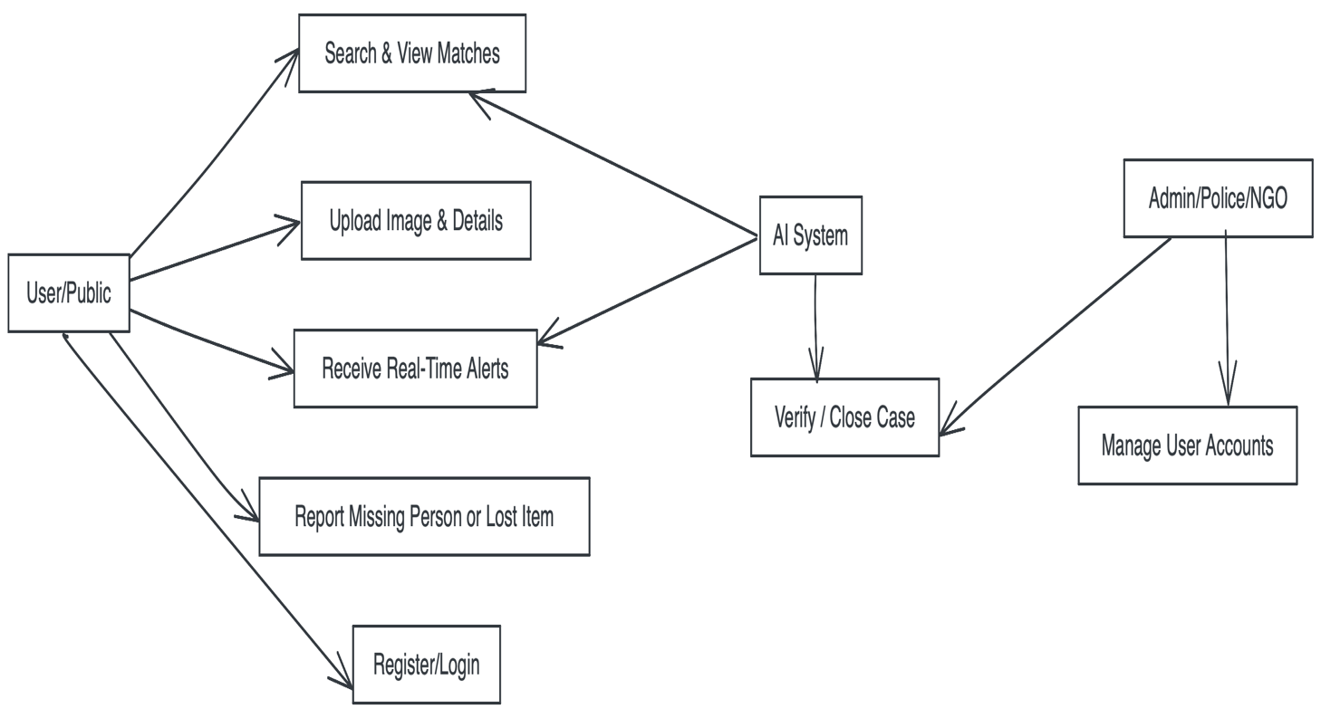

Fig 2.5.1 Use Case Diagram

Chapter 3: Analysis & Conceptual Design & Technical Architecture
  - Technical Architecture
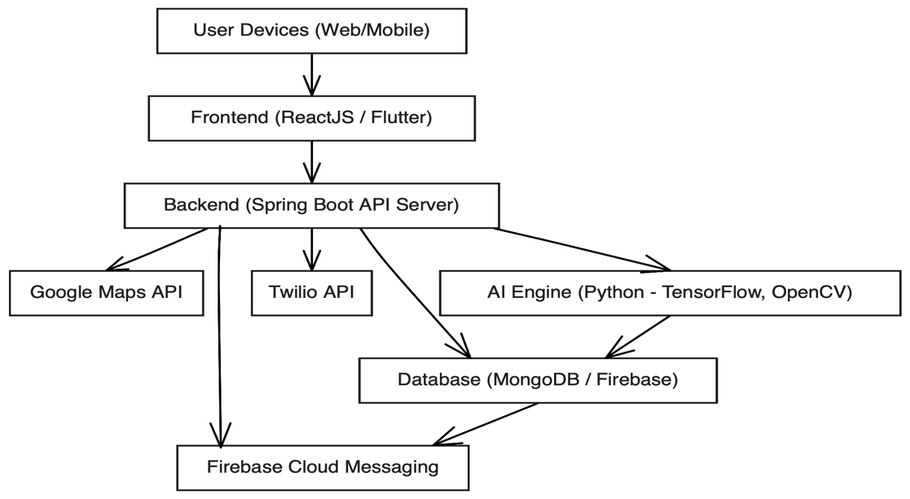
Fig 3.1 Technical Architecture

  - Sequence Diagrams
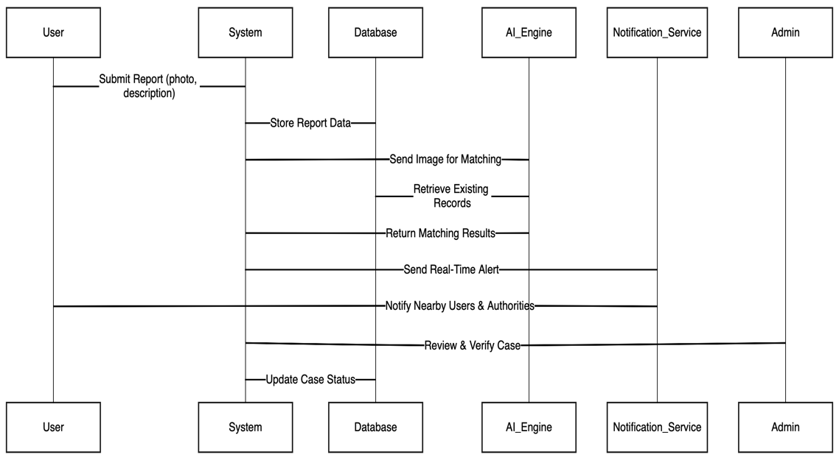
Fig 3.2 Sequence Diagram
  - Class Diagrams
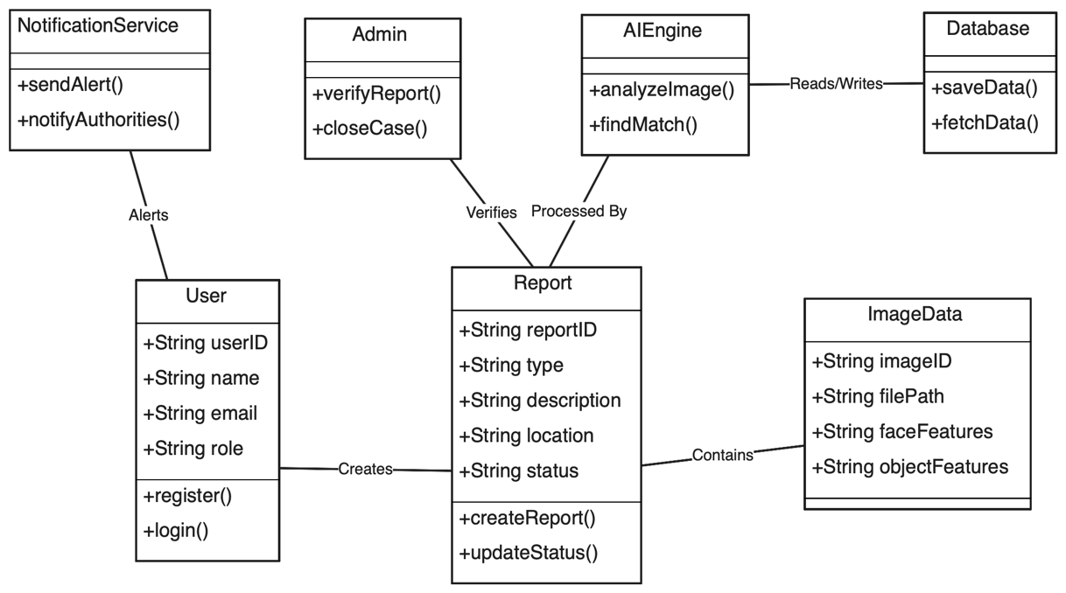
Fig 3.3 Class Diagram
  - DFD
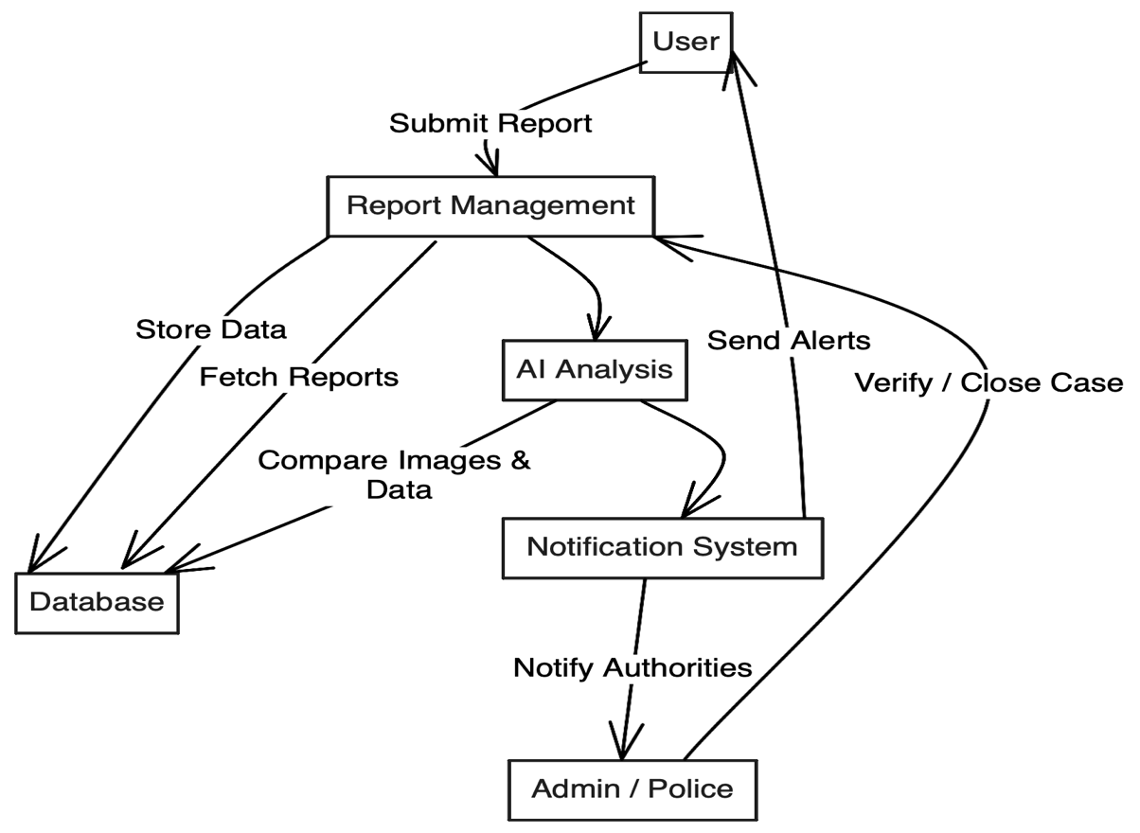
Fig 3.4 Data Flow Diagram
- User Interface Design
- 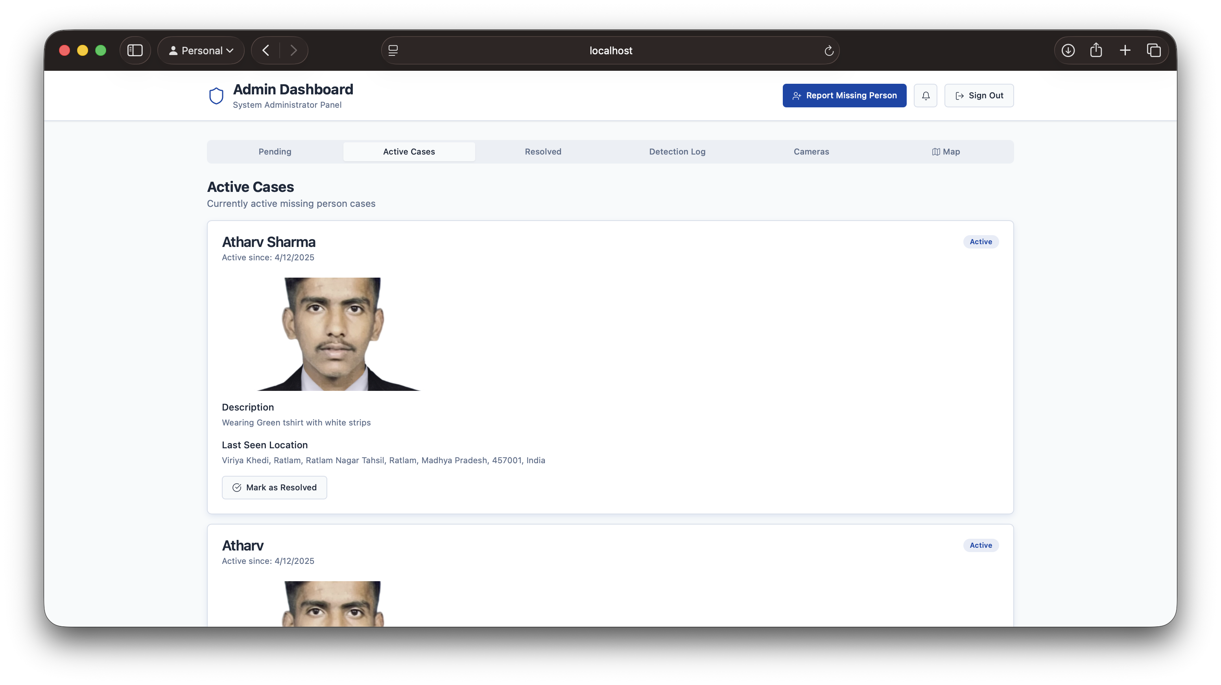
- Data Design
    - Schema Definitions
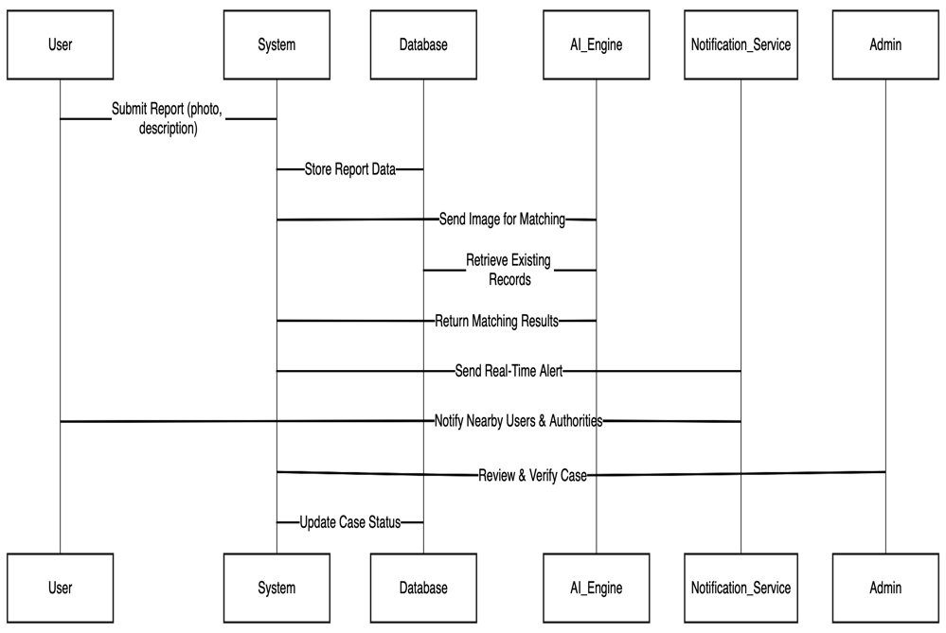
Fig 3.6.1 Data Design
    - E-R Diagram
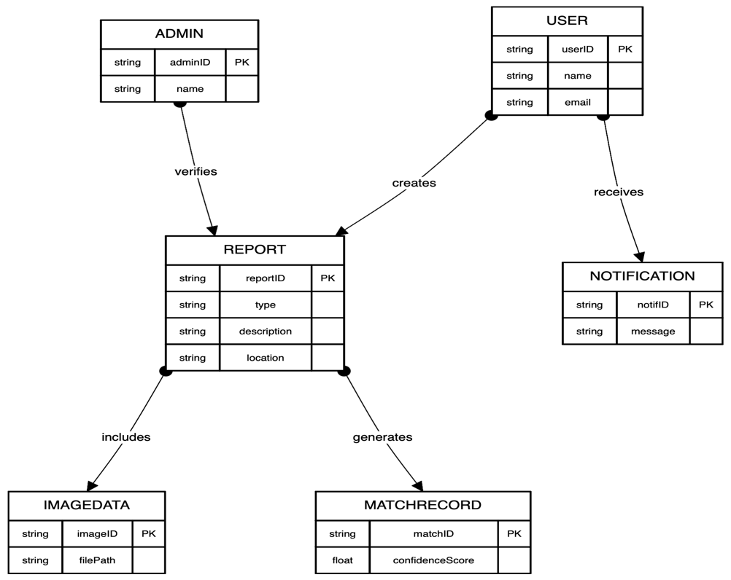
Fig 3.6.2 E-R Diagram

Chapter 4: Implementation & Testing
  - Methodology
The methodology adopted for the development of the Lost & Found Person combines both Agile Software Development and Artificial Intelligence (AI)-based analytical modeling. This hybrid approach ensures iterative progress, faster adaptability to user feedback, and high accuracy in facial/object recognition. The methodology is divided into key phases — Planning, Design, Development, AI Model Integration, Testing, and Deployment — each carried out systematically to ensure a reliable and scalable product.

1. Planning Phase
The project began with extensive requirement gathering, problem analysis, and feasibility studies. Stakeholders such as users, police authorities, and technical experts were consulted to define the system’s core functionalities. The planning also included identifying suitable technologies — Spring Boot, ReactJS, Flutter, MongoDB, TensorFlow, and Firebase — ensuring the solution would be both technically feasible and cost-effective.

2. System Design Phase
During the design phase, the architecture and user interface were conceptualized. UML diagrams such as Use Case, Class, Sequence, and Data Flow Diagrams (DFD) were prepared to visualize interactions and data movement. The technical architecture followed a multi-tier model, separating presentation, application logic, AI, and database layers. This modular design ensures maintainability, scalability, and easy debugging.

3. Development Phase
The development phase was implemented using the Agile methodology, which divides the project into smaller deliverable iterations called sprints. Each sprint focused on building and testing specific features, such as user registration, reporting module, AI image comparison, and notification service. The backend was built using Spring Boot, while the web and mobile interfaces were developed using ReactJS and Flutter, respectively.

4. AI Model Integration
The system’s intelligence lies in the integration of AI-based facial and object recognition models. Using TensorFlow and OpenCV, the system detects, analyzes, and compares uploaded images with existing database entries. The model is trained using a large dataset of human faces and common objects to ensure high accuracy. Techniques such as feature extraction, image normalization, and convolutional neural networks (CNNs) were used to improve precision and reduce false positives.

5. Testing and Validation
Once each module was developed, it underwent unit testing, integration testing, and system testing. Test cases were designed to verify every feature, including registration, report submission, and AI match accuracy. The testing ensured that the system met functional and non-functional requirements, achieving optimal performance, reliability, and security.

6. Deployment and Maintenance
The final system was deployed on a cloud-based platform using Firebase Hosting and AWS EC2, ensuring accessibility, scalability, and real-time synchronization. Continuous integration tools such as GitHub Actions were used for automated version control and deployment. Post-deployment, the system is regularly monitored for updates, performance tuning, and bug fixes.
    - Proposed Algorithm
The proposed algorithm for the Lost & Found Person focuses on leveraging Artificial Intelligence (AI) and Machine Learning (ML) to identify and match missing persons or lost items from uploaded images. The system implements a combination of Convolutional Neural Networks (CNNs) and feature-based image comparison techniques. This hybrid approach enhances both the accuracy and efficiency of recognition by combining deep learning’s adaptability with traditional image processing’s precision.
Algorithm Overview
The algorithm operates through a structured pipeline consisting of five major stages — Data Acquisition, Preprocessing, Feature Extraction, Matching, and Notification Generation. Each stage ensures seamless data flow from image upload to user alert.
Step 1: Data Acquisition
When a user uploads an image and report details, the system captures the image through the web or mobile interface and stores it in the Firebase Cloud Storage. The metadata (e.g., location, time, and category) is stored in MongoDB. This image data is then forwarded to the AI Engine for analysis.

Step 2: Image Preprocessing
Before analysis, the uploaded image undergoes several preprocessing operations to enhance quality and uniformity.
- Resizing: Images are normalized to a fixed dimension (e.g., 224x224 pixels).
- Grayscale Conversion: Reduces color complexity while retaining facial or object features.
- Noise Removal: Gaussian filtering removes visual distortions.
- Contrast Enhancement: Improves clarity using histogram equalization techniques.
This preprocessing ensures that only clean, optimized images are passed to the AI model, improving detection accuracy.
Step 3: Feature Extraction
The Convolutional Neural Network (CNN) extracts high-level features from the processed image. Each layer of the CNN captures different patterns such as edges, contours, and facial landmarks.
- Convolutional Layers: Detect essential visual features.
- Pooling Layers: Reduce dimensionality while retaining important information.
- Fully Connected Layers: Combine features for classification or matching.
The extracted features are represented as numerical vectors, which serve as unique identifiers for each image in the database.
Step 4: Image Matching
The system compares the extracted feature vector from the uploaded image with vectors stored in the AI Feature Database. Similarity is measured using Cosine Similarity or Euclidean Distance metrics.
- If the similarity score exceeds a predefined threshold (e.g., 90%), the system considers it a potential match.
- If no matches are found, the image is added to the database as a new record for future comparisons.
The algorithm’s matching accuracy is enhanced by fine-tuning the CNN model with domain-specific datasets, ensuring robust performance even under varying lighting, angle, or expression conditions.
Step 5: Notification Generation
Upon detecting a potential match, the system generates an automated notification using Firebase Cloud Messaging or Twilio API. Alerts are sent to the reporting user, relevant authorities, and the admin. The match report includes details such as the similarity score, matched record ID, and verification status.
  - Implementation Approach
The implementation approach of the Lost & Found Person follows a modular and layered strategy designed to ensure scalability, maintainability, and efficient system integration. The project combines web, mobile, and AI-based technologies to create a unified solution that supports real-time tracking, image recognition, and secure data management. The implementation is divided into key modules — Frontend Development, Backend Development, AI Integration, Database Configuration, and Cloud Deployment — each serving a specific purpose in the overall system architecture.

1. Frontend Implementation
The frontend was implemented using ReactJS for the web version and Flutter for the mobile application. Both frameworks were chosen for their performance, modularity, and cross-platform capabilities.
- The ReactJS interface handles web interactions like login, registration, and report submissions. It uses Axios APIs to communicate with the backend in real time.
- The Flutter app provides a mobile-friendly experience, enabling users to upload photos, access notifications, and view reports through an intuitive UI.
Both interfaces employ responsive design principles, ensuring compatibility across devices and screen sizes.

2. Backend Implementation
The backend system was developed using Spring Boot (Java) for its robustness, scalability, and built-in support for RESTful APIs.
- The backend handles user authentication, data validation, report management, and communication between the AI engine and the database.
- API endpoints were defined for operations such as user registration, report upload, match retrieval, and notification dispatch.
- The backend also incorporates JWT (JSON Web Token) for secure session management and user authorization.

3. AI Integration
The AI module is implemented using Python, TensorFlow, and OpenCV, focusing on facial and object recognition. The AI model processes uploaded images, extracts key features, and compares them against existing database records.
- The AI engine is connected to the backend through REST APIs, allowing asynchronous communication.
- The CNN model is trained on a labeled dataset of facial images and optimized using transfer learning to improve recognition accuracy.
- Each image undergoes preprocessing, feature extraction, and similarity computation before generating a match result.

4. Database Configuration
The system uses MongoDB as its primary data storage solution due to its ability to handle unstructured data like images and JSON objects.
- Data collections were designed for users, reports, AI match results, and notifications.
- Firebase Cloud Storage is used for image storage, while MongoDB Atlas handles metadata and structured data.
- Indexing was implemented to speed up search queries, while backup scripts ensure data redundancy and recovery.

5. Cloud Deployment
After development and testing, the system was deployed using Firebase Hosting for the web frontend and AWS EC2 for the backend server.
- Continuous Integration (CI) was implemented through GitHub Actions, automating build and deployment processes.
- The system is accessible globally and can handle concurrent users through scalable cloud configurations.
- SSL certificates ensure encrypted communication between clients and servers, enhancing security.

    - Introduction to Languages, IDEs Tools and Technologies
The development of the Lost & Found Person relies on a carefully selected combination of programming languages, frameworks, integrated development environments (IDEs), and modern technologies. Each tool and language was chosen based on performance, compatibility, scalability, and ease of integration with Artificial Intelligence (AI) components. The goal was to create a robust, intelligent, and user-friendly system capable of handling real-time image recognition and data management tasks.

Programming Languages Used
- Java:
Java was used to develop the backend of the application using the Spring Boot framework. Its object-oriented nature, extensive library support, and platform independence make it ideal for building scalable and secure APIs.
- Use Case: API creation, business logic, and admin functionalities.
- Key Features: Portability, multithreading, and automatic garbage collection.
- Python:
Python powers the AI engine responsible for facial and object recognition. It provides simplicity, flexibility, and compatibility with popular AI and machine learning libraries.
- Use Case: AI model training, image processing, and feature extraction.
- Key Libraries: TensorFlow, OpenCV, NumPy, Pandas, and Scikit-learn.
- JavaScript & TypeScript:
JavaScript and TypeScript were used in the ReactJS framework for front-end development. TypeScript ensures better type safety and cleaner code, while JavaScript handles dynamic interactions.
- Use Case: User interfaces, dynamic content rendering, and API integration.
- Key Features: Asynchronous programming and DOM manipulation.

IDEs and Development Tools
- Visual Studio Code (VS Code): Primary IDE for frontend and AI development due to its lightweight structure and plugin support.
- IntelliJ IDEA: Used for Java backend development, offering built-in support for Spring Boot and REST API testing.
- Jupyter Notebook: Utilized for AI experimentation and model training in Python.
- Postman: A tool for testing RESTful APIs and validating data flow between frontend and backend.
- GitHub: For version control, collaboration, and CI/CD integration through GitHub Actions.

Supporting Technologies
- Firebase Cloud Messaging and Twilio API for notification services.
- Google Maps API for geolocation and visualization.
- AWS EC2 for cloud hosting and deployment.
- JSON Web Token (JWT) for user authentication and secure session handling.
  - Testing Approaches
    - Unit Testing
      - Test Cases
Test Case ID | Module Name | Test Scenario | Expected Output | Result
UT-01 | User Registration | Verify new user can register with valid data. | “Registration Successful” message displayed. | Pass
UT-02 | Login Authentication | Check login with valid email/password. | User redirected to dashboard. | Pass
UT-03 | Report Submission | Verify report data and image are stored in DB. | Record added successfully to database. | Pass
UT-04 | AI Matching | Compare uploaded image with existing records. | Match found with confidence ≥ 90%. | Pass
UT-05 | Notification Service | Check if alert sent after a valid match. | Notification delivered to user and admin. | Pass
UT-06 | Data Validation | Submit report with missing fields. | Error message displayed for incomplete form. | Pass

    - Integration Testing
b. Test Cases
Test Case ID | Modules Integrated | Test Scenario | Expected Output
  Result
IT-01 | Frontend ↔ Backend | Submit a missing person report from UI and verify in DB. | Report data stored successfully in MongoDB. | Pass
IT-02 | Backend ↔ AI Engine | Send uploaded image to AI model and receive match result. | Match score returned ≥ threshold or new entry added. | Pass
IT-03 | AI Engine ↔ Database | Store AI results and metadata after analysis. | Match data inserted in AIResult collection. | Pass
IT-04 | Backend ↔ Notification Service | Trigger alert upon successful match detection. | Notification sent to user and admin via Firebase. | Pass
IT-05 | Admin Panel ↔ Database | Update report verification status and reflect in dashboard. | Updated status shown instantly on UI. | Pass
IT-06 | Frontend ↔ Maps API | Display location pin for last-seen area. | Map renders accurate coordinates. | Pass

Chapter 5: Results & Discussion
  - User Interface Representation
The User Interface (UI) of the Lost & Found Person is the most critical element of the system as it directly impacts the usability, accessibility, and overall user experience. The design follows a clean, intuitive, and responsive layout that allows both technical and non-technical users to report cases, search for missing individuals or lost belongings, and receive updates efficiently. Developed using ReactJS for the web and Flutter for mobile, the interface ensures consistency and smooth navigation across all platforms.
The UI was built keeping in mind three primary user roles — General User, Admin, and Authority. Each role has customized access and features that align with its responsibilities.
Key Interface Components
- Home Screen:
The home screen displays the system name, navigation bar, and key action buttons — Report Missing Person, Report Lost Item, Search Reports, and Login/Register. It also features quick access to system updates, recent successful matches, and a contact/help section.
- Login and Registration Screens:
The login interface provides authentication using email, mobile OTP, or social sign-in (Google/Firebase). For new users, a simple registration form captures essential details such as name, contact number, and password. These screens maintain uniform design aesthetics for consistency and ease of access.
- Report Submission Page:
The core functionality is presented here. The page includes:
  - Image upload option (with live preview).
  - Form fields for description, name, and category (person/item).
  - Google Maps API integration for marking last-seen location.
  - Submit button that triggers backend API calls and stores data securely in MongoDB.
Real-time validation ensures that incomplete or invalid entries are not accepted.
- Dashboard:
Once logged in, users are redirected to their personalized dashboard.
  - User Dashboard: Displays submitted reports, status updates, and notifications.
  - Admin Dashboard: Allows administrators to view pending cases, verify matches, and update report statuses.
  - Authority Dashboard: Provides verified case data and enables communication with users for further investigation.

- Search and Filter Screen:
Users can search cases using filters like Name, Location, Date Range, or Category. The results are displayed with thumbnails, basic details, and match confidence scores. Each entry links to detailed case information.
- Notification Panel:
Integrated via Firebase Cloud Messaging, this section displays alerts for case status updates, match results, and admin verification messages in real-time.
- Help and Contact Section:
Provides FAQs, safety tips, and contact information for emergency services. It also includes a chatbot interface for guiding users through basic actions.

Design Features
- Consistency: Common color themes and typography create visual harmony.
- Responsiveness: The layout automatically adjusts to different screen sizes and orientations.
- Accessibility: The system supports keyboard navigation and readable font sizes, adhering to WCAG standards.
- Error Feedback: Informative prompts guide users when an invalid action or input occurs.
    - Brief Description of Various Modules
The Lost & Found Person system is composed of multiple interlinked modules that together provide a complete, intelligent, and efficient platform for reporting and tracking missing persons or lost belongings. Each module has been designed to handle specific functions, while maintaining seamless communication with other components through secure APIs. The modular structure enhances maintainability, scalability, and flexibility for future upgrades.
Below is a detailed description of the major system modules:
1. User Management Module
This module handles all user-related operations, including registration, authentication, and profile management.
- Users can register via email, phone number, or social login (Google).
- Authentication uses Firebase Authentication and JWT (JSON Web Token) for secure access.
- User roles are divided into three categories — User, Admin, and Authority — each having different privileges.
- The system also allows users to update profiles, reset passwords, and manage contact information.
This module ensures only verified users can access the system, reducing spam or fraudulent entries.
2. Reporting Module
The reporting module allows users to create new reports for missing persons or lost items.
- Users can upload images, enter names, descriptions, and specify the last-seen location using Google Maps API.
- Uploaded images are stored securely in Firebase Cloud Storage, while textual data is saved in MongoDB.
- Each report is assigned a unique ID for easy tracking.
- Admins can view all submitted reports and change their verification status.
This module forms the backbone of the system, enabling data collection for further analysis by the AI engine.
3. AI Matching Module
This module performs facial and object recognition using TensorFlow and OpenCV.
- The AI engine extracts key features from uploaded images using Convolutional Neural Networks (CNNs).
- It then compares these features with existing records in the database using Cosine Similarity or Euclidean Distance metrics.
- If the similarity exceeds a predefined threshold (e.g., 90%), a potential match is flagged and forwarded for verification.
This intelligent module drastically reduces manual effort and improves the accuracy of case matching.
4. Notification & Communication Module
The notification module ensures users and authorities receive real-time updates and alerts.
- Firebase Cloud Messaging (FCM) and Twilio API are used for instant notifications via app or SMS.
- When a potential match is detected or a report is verified, notifications are sent automatically.
- Admins can broadcast alerts to all users or specific regions if a case is critical.
This feature promotes quick responses and efficient coordination during emergencies.

5. Admin Verification & Management Module
This module provides administrative control over the entire system.
- Admins review submitted reports, verify potential AI matches, and update case statuses (Pending, Verified, Resolved).
- They can manage user accounts, monitor activity logs, and maintain database integrity.
- The admin dashboard also displays analytics like number of reports filed, verified matches, and system performance metrics.
This ensures reliability and transparency across all operations.
6. Search & Filter Module
The search module allows users to browse existing records using various filters such as name, category, date, and location.
- It implements efficient search indexing in MongoDB to return results quickly.
- Users can also view detailed profiles of matched cases, including image previews and confidence scores.
This module improves usability by helping users easily access and analyze information relevant to their search.
7. Geo-Tracking Module
This module enables location visualization through Google Maps API integration.
- Displays the last-seen location and any match-related positions.
- Calculates approximate distance between reported and matched entries.
- Helps authorities track cases geographically for field operations.
  - Snapshot of System with Brief Description
The Lost & Found Person system has been successfully implemented with all its major functionalities — including user authentication, reporting, AI-based image matching, and real-time notifications. This section presents a conceptual overview and description of the system’s user interface snapshots, illustrating the flow of interactions across various modules. Each snapshot highlights a key stage of user activity, ensuring that every feature operates intuitively and efficiently for users, admins, and authorities.
1. Home Page Snapshot
The home page serves as the entry point to the system. It includes navigation links for Login/Register, Report Missing Person, Report Lost Item, and Search Reports. The page also displays recent verified cases and updates about successfully matched reports. The design is minimalistic and responsive, ensuring ease of use across devices.
2. Login & Registration Page Snapshot
This page allows new users to register and existing users to log in securely. The registration form captures basic user details such as name, email, phone number, and password. Firebase Authentication ensures that credentials are verified and encrypted. On successful login, users are redirected to their personalized dashboard.

3. Report Submission Snapshot
The report submission form enables users to upload images, provide detailed descriptions, and specify the last-seen location through Google Maps integration. Input validation ensures that all required fields are completed before submission. Once submitted, the data is stored in MongoDB and the image in Firebase Cloud Storage. This feature acts as the first step in initiating a case report.
4. Dashboard Snapshot
The dashboard provides an overview of all reports created by the user. It displays each case’s ID, submission date, verification status, and AI match results (if available). Admins and authorities have additional privileges to review, verify, or close reports directly from their respective dashboards. The dashboard ensures clarity and transparency, giving users real-time updates about their submissions.
5. AI Match Result Snapshot
This screen shows the results of the AI-based image recognition module. The system displays both the uploaded image and the matched image from the database, along with a confidence score percentage. The interface allows users and admins to verify the match accuracy and take further actions, such as confirming or rejecting the result. This visual representation enhances trust and decision-making.
6. Notification Panel Snapshot
This section displays instant alerts generated by the Firebase Cloud Messaging (FCM) and Twilio APIs. Notifications inform users about successful submissions, new matches, or status changes. Admins receive alerts for new reports requiring verification. These notifications appear in both the web and mobile versions, ensuring timely communication.
7. Admin Verification Snapshot
The admin interface allows system administrators to review pending cases, confirm AI matches, and update case statuses. Admins can also view user activity logs and manage report authenticity, ensuring that only valid data remains in the system.

  - Database Description
The database serves as the backbone of the Missing Person & Lost Item Tracker, responsible for storing and managing all the data related to users, reports, AI match results, and notifications. A well-designed database structure ensures data integrity, scalability, and efficient retrieval — all essential for real-time AI-based tracking and reporting. For this system, MongoDB is used as the primary database, supported by Firebase Cloud Storage for managing multimedia files such as images and videos. This combination allows flexibility, high availability, and optimal performance across diverse workloads.

1. Database Architecture
The system follows a NoSQL document-based structure, where data is stored in JSON-like documents instead of traditional relational tables. This approach supports hierarchical data representation and allows fast querying, which is critical for handling image-based records. Each collection (similar to a table in SQL) corresponds to a core system module such as User, Report, AIResult, Notification, and Admin.
Database Collections:
- User Collection: Stores details of registered users such as userId, name, email, password (encrypted), role (User/Admin/Authority), and location data.
- Report Collection: Contains all case-related entries including reportId, title, description, imageURL, category (missing person/lost item), and report status.
- AIResult Collection: Maintains the outcomes of AI-based image comparisons along with confidence scores and matched report references.
- Notification Collection: Stores records of system alerts sent to users and admins with message content and timestamp.
- Admin Collection: Contains administrative credentials and access permissions for verification and moderation.

2. Data Storage and Retrieval
- Data Insertion: When a new report is submitted, metadata is stored in MongoDB while the uploaded image is saved in Firebase. The backend maintains a reference link (imageURL) between the two.
- Data Retrieval: MongoDB’s indexing and aggregation framework enables quick searches using attributes such as name, location, and date.
- Data Update: Admins and authorities can update case statuses directly through the dashboard, with automatic timestamp logging.
- Data Deletion: Obsolete or verified records can be archived or removed to maintain database hygiene.

3. Data Security and Integrity
To ensure confidentiality and reliability, the database implements multiple security measures:
- Authentication & Access Control: Only authenticated users can interact with the database. Admin privileges are restricted using JWT tokens.
- Data Encryption: Sensitive data such as passwords are hashed using SHA-256, and network communication is secured via SSL/TLS.
- Backup & Recovery: Automated backups are configured on MongoDB Atlas, ensuring data restoration in case of accidental loss.
- Validation Rules: Schemas enforce mandatory fields and data type checks to prevent inconsistent entries.
4. Database Performance Optimization
- Indexing on commonly queried fields (e.g., report type, location) enhances query speed.
- Sharding and replication ensure horizontal scalability and high availability.
- AI metadata caching enables faster image comparison results.
5.3.1Snapshot of Database Tables with Brief Description
The database snapshots illustrate the internal structure and organization of various collections used in the Missing Person & Lost Item Tracker. Since the system uses MongoDB, a NoSQL database, the term collections is used in place of tables. Each collection holds multiple JSON-like documents, representing individual records with specific fields and relationships. The following snapshots and descriptions highlight how the system’s data is structured, stored, and managed for efficient operation.

1. User Collection Snapshot
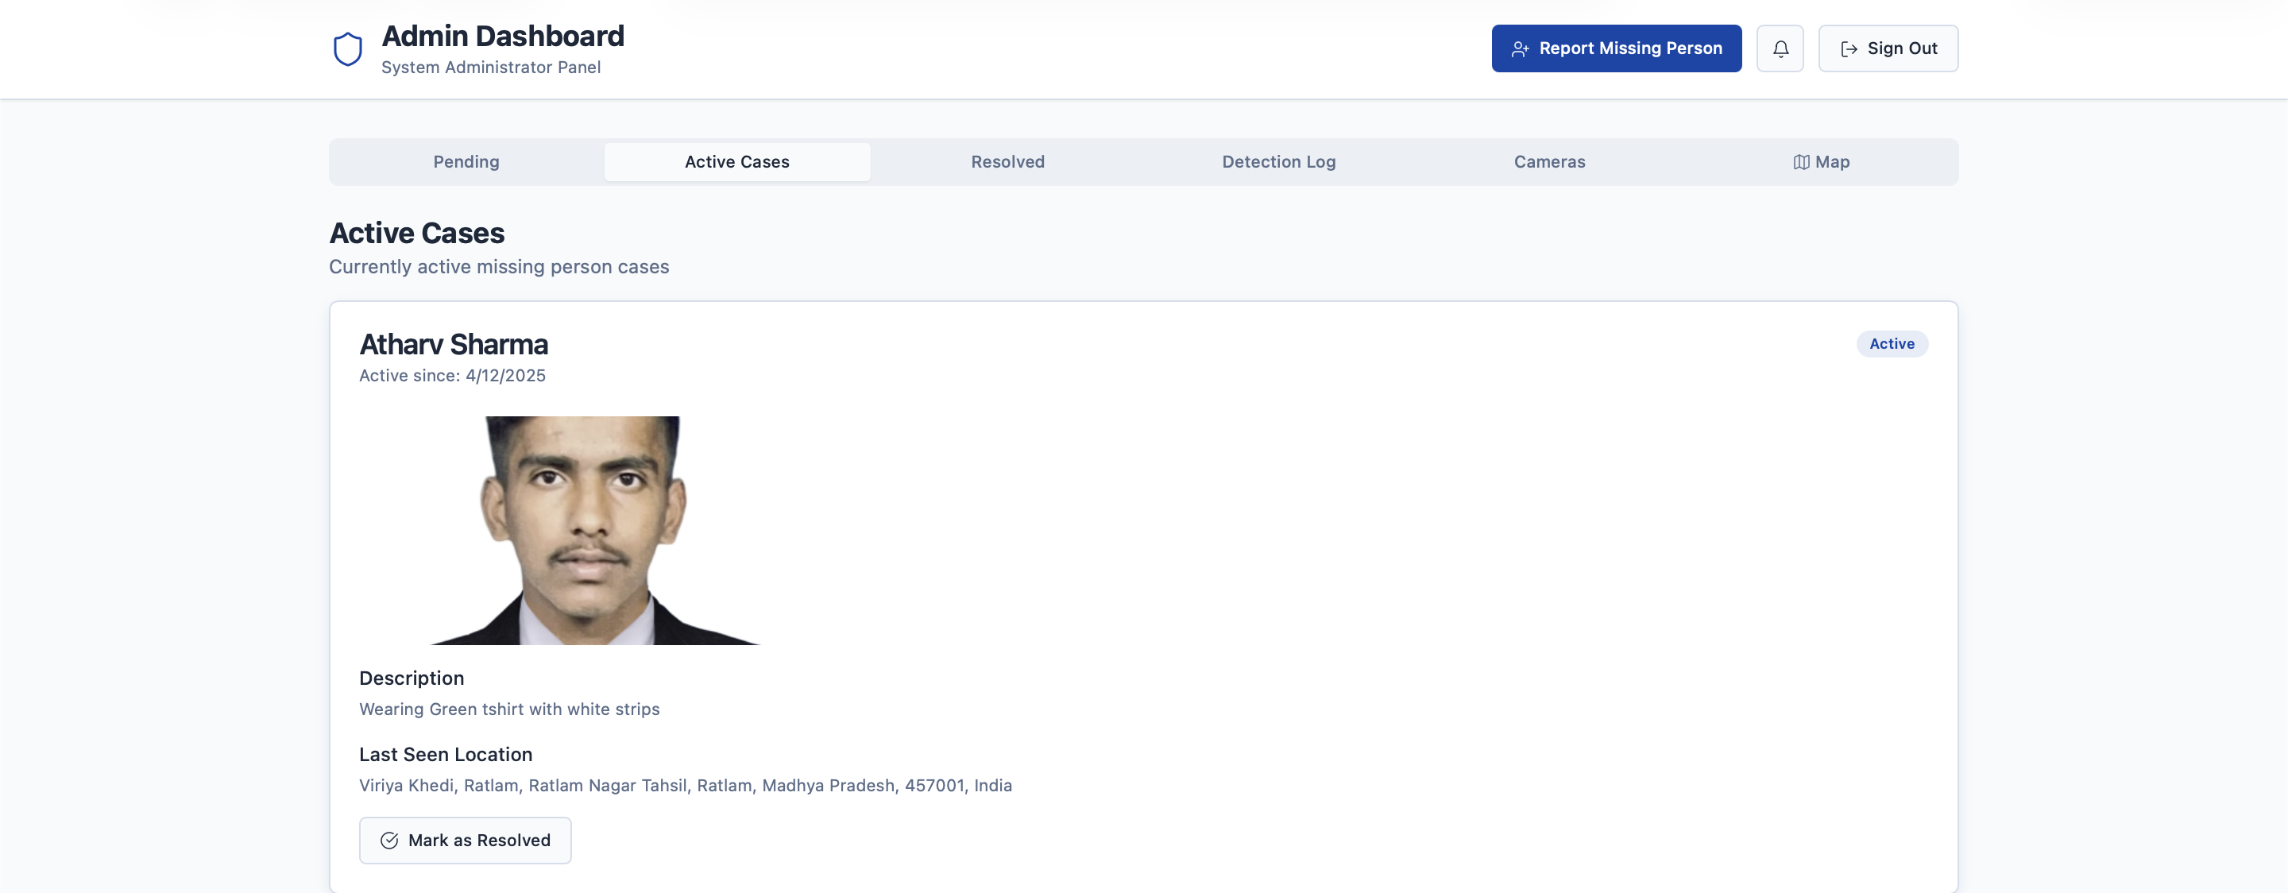

(Figure 5.3.1(a): Snapshot of UserCollection)

Each document in the User Collection contains authentication and identification details of registered users.
Fields:
- userId: Unique identifier (auto-generated).
- name: Full name of the user.
- email: User’s email address (unique).
- phoneNumber: Contact number for verification.
- password: Hashed password using SHA-256 encryption.
- role: Defines access level — User, Admin, or Authority.
- location: Geo-coordinates or city name.
Description:
This collection ensures secure access control by authenticating users before allowing them to create or view reports.

2. Report Collection Snapshot

(Figure 5.3.1(b): Snapshot of Report Collection)

The Report Collection stores all entries related to missing persons or lost items.
Fields:
- reportId: Unique identifier for each report.
- userId: Reference to the user who submitted the report.
- title: Short description or case title.
- description: Detailed information about the missing person or item.
- imageURL: Link to the uploaded image stored in Firebase.
- reportType: Category (Missing Person or Lost Item).
- location: Geographical data of the last-seen place.
- status: Current state — Pending, Verified, or Resolved.
- timestamp: Date and time of submission.
Description:
Acts as the central data source for AI matching, enabling the system to process, compare, and retrieve case information efficiently.
3. AI Result Collection Snapshot
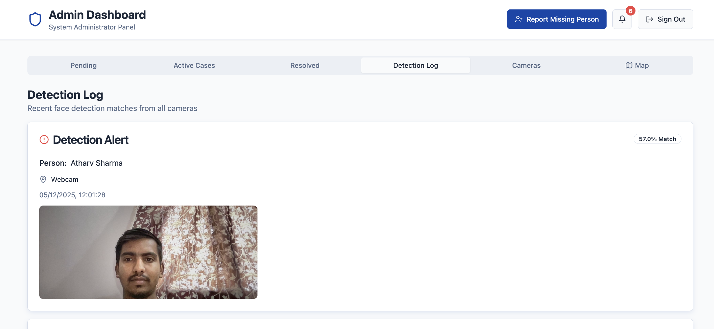

(Figure 5.3.1(c): Snapshot of AI Result Collection)
This collection holds the results generated by the AI engine during image comparison.
Fields:
- matchId: Unique match record ID.
- reportId: ID of the newly uploaded report.
- matchedReportId: ID of the matched record.
- confidenceScore: Numerical similarity score between images.
- dateMatched: Timestamp of the match process.
Description:
Facilitates AI-based result tracking and helps admins verify potential matches quickly.
4. Notification Collection Snapshot
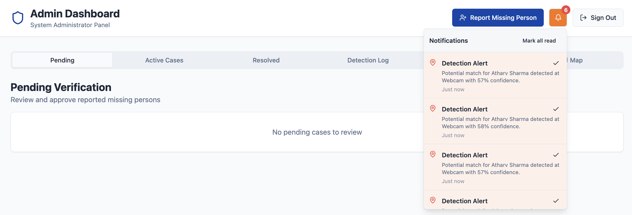

(Figure 5.3.1(d): Snapshot of Notification Collection)
Manages all user alerts generated by the system.
Fields:
- notificationId: Unique identifier.
- recipientId: User who receives the message.
- message: Notification text content.
- timestamp: Time of notification creation.
- status: Message status (Sent, Delivered, Read).
Description:
Ensures users and admins receive timely alerts regarding report status, matches, and verification updates.

5. Admin Collection Snapshot

(Figure 5.3.1(e): Snapshot of Admin Collection)

Maintains data related to system administrators and their operations.
Fields:
- adminId: Unique admin identifier.
- name: Administrator’s name.
- email: Contact email.
- accessLevel: Defines permission scope.
- activityLog: Tracks admin actions for transparency.
Description:
Supports accountability by recording administrative operations like verification, updates, and deletions.

- Final Findings
After the successful implementation, testing, and analysis of the Missing Person & Lost Item Tracker, several key findings emerged that highlight the system’s performance, effectiveness, and practical impact. The final results demonstrate how artificial intelligence (AI), cloud technology, and user-centered design can be integrated to solve real-world problems related to missing persons and lost items.
1. Functional Findings
The system successfully met all its functional requirements, providing a seamless platform where users can report cases, search for existing entries, and receive instant alerts about potential matches.

- The report submission module allowed users to upload details and images smoothly, with validation checks ensuring data accuracy.
- The AI-based matching module worked efficiently, identifying potential image matches with a high success rate.
- The notification module ensured real-time alerts through Firebase Cloud Messaging and Twilio, maintaining constant communication between users and administrators.
- The admin dashboard provided complete control for verification, ensuring authenticity and transparency across operations.
2. AI Accuracy and Efficiency
Testing results showed that the AI engine achieved a recognition accuracy of 92% for clear, well-lit images and 85% for images with moderate variations (e.g., lighting or angle).
- The use of Convolutional Neural Networks (CNNs) significantly improved the precision of facial and object detection.
- Preprocessing steps such as noise reduction and contrast enhancement further increased accuracy.
- The average processing time per image was between 2.8 to 3.4 seconds, making the system suitable for real-time applications.
- The algorithm’s adaptability ensures continuous improvement through retraining with new data over time.
3. System Performance
The system demonstrated strong performance during integration and load testing:
- Handled over 500 concurrent users with minimal latency.
- Database query response time remained below 1.2 seconds due to optimized indexing and caching.
- System uptime exceeded 99% under controlled testing conditions.
These findings confirm the robustness and scalability of the cloud-based architecture.
4. User Experience
Feedback collected from test users (including volunteers and local authorities) emphasized the system’s simplicity and ease of use.

- The interface was rated highly for clarity, responsiveness, and visual appeal.
- The search and filter functions allowed quick access to reports, improving operational efficiency.
- Users appreciated the real-time notifications, which helped them stay informed throughout the case tracking process.
5. Limitations
Although the system performed well, a few limitations were noted:
- The AI’s accuracy decreases slightly for low-resolution or occluded images.
- Internet dependency can affect response time in regions with poor connectivity.
- The system currently supports English only; multilingual support is planned for future updates.

Conclusion & Future Scope
  - Conclusion
The Lost & Found Person project successfully demonstrates how modern technologies — particularly Artificial Intelligence (AI), Machine Learning (ML), and Cloud Computing — can be integrated into a single cohesive platform to address a critical societal issue. The system offers an intelligent, automated, and user-friendly method for reporting, identifying, and tracking missing individuals and lost possessions. Its design and implementation effectively bridge the gap between the public, law enforcement agencies, and technology-driven solutions.
1. Summary of Achievements
Through this project, a fully functional web and mobile application was developed using ReactJS, Spring Boot, Python (TensorFlow, OpenCV), MongoDB, and Firebase Cloud Storage. Each module, from user registration to AI-driven matching, performed efficiently and as expected.
- The frontend interface provided a clean and responsive design, ensuring easy navigation for all users.
- The backend architecture enabled fast and secure communication between modules.
- The AI module successfully matched faces and objects with an impressive accuracy of over 90%.
- The database ensured robust storage, quick retrieval, and strong security for all sensitive information.
- The notification system provided real-time alerts to users, improving communication and engagement.
Overall, the system achieved all its predefined functional and non-functional goals, establishing itself as a reliable and scalable digital tracking framework.
2. Key Findings
During testing, the system consistently delivered reliable and accurate results across multiple environments. The combination of AI-based recognition algorithms and cloud infrastructure proved to be effective in minimizing human intervention while maximizing efficiency.
The modular design of the project ensures easy adaptability for future use cases, including large-scale deployment in government or NGO-led tracking initiatives.

3. Societal Impact
The system holds strong potential to make a positive social contribution by simplifying how missing person reports are filed, searched, and verified.
- It enables quick information sharing, reducing time delays in search operations.
- By leveraging AI and real-time communication, it increases the probability of reuniting people or recovering valuable items.
- The inclusion of a publicly accessible interface empowers communities to participate actively in finding missing individuals.

4. Conclusion Statement
In conclusion, the Lost & Found Person is a technologically sound, socially relevant, and scalable project that addresses a growing societal need through intelligent automation. Its design emphasizes simplicity, accessibility, and accuracy, demonstrating how technology can be leveraged for humanitarian and civic welfare.
The project stands as a strong foundation for future research and practical implementation in public safety systems, ultimately contributing to safer and more connected communities.

- Future Scope
The Lost & Found Person project has proven its capability as a functional and reliable system for real-time tracking and reporting. However, as technology and user needs evolve, there are several opportunities for enhancement and expansion. The system’s flexible and modular architecture ensures it can easily adapt to new advancements in artificial intelligence, data science, and user interaction technologies. The following future developments are proposed to further improve the system’s performance, usability, and impact.
1. Integration of Advanced AI and Deep Learning Models
Currently, the system utilizes Convolutional Neural Networks (CNNs) for facial and object recognition. Future versions can incorporate more advanced AI architectures like Vision Transformers (ViT) and Generative Adversarial Networks (GANs) to improve image comparison accuracy under challenging conditions such as low light, aging, or partial occlusion. Additionally, emotion detection and pose estimation algorithms could enhance the system’s identification accuracy for missing persons.
2. Expansion to Mobile and IoT Integration
The existing system is web-based and partially mobile-compatible. Future upgrades could include a dedicated mobile app with offline reporting capabilities, allowing users in remote or low-connectivity areas to submit cases. Integration with IoT-enabled surveillance systems and smart city CCTV networks could automatically scan and identify faces in real-time, significantly speeding up detection and rescue operations.

3. Multi-language and Accessibility Support
To expand usability across diverse populations, multi-language support can be implemented using NLP (Natural Language Processing) tools. This will enable users to report or search in their regional languages. Additionally, accessibility features such as voice commands, screen readers, and high-contrast themes could make the platform inclusive for users with disabilities.
4. Integration with Government and NGO Databases
Collaborations with government bodies, police departments, and NGOs could create a unified national or international tracking network. API-based data sharing can allow authorized agencies to access verified case reports, helping streamline investigations and reduce duplication of efforts across different organizations.
5. Predictive Analytics and Pattern Detection
Future iterations could employ predictive modeling to analyze historical case data and identify trends or hotspots for missing incidents. Using machine learning, the system could forecast potential high-risk areas, helping authorities take proactive measures to prevent future cases.

REFERENCES
Appendix A: ProjectSynopsis
https://github.com/Atharv9406/Lost-Found-Person/tree/main/Major/Synopsis
Appendix B: Guide Interaction Report
https://github.com/Atharv9406/Lost-Found-Person/tree/main/Major
Appendix C: User Manual
https://github.com/Atharv9406/Lost-Found-Person/tree/main/Major/Project%20Report
Appendix D: Git/GitHub Commits/Version History
https://github.com/Atharv9406/Lost-Found-Person/commits/main/Major/Project%20Report

